GREEN HOUSE MONITORING AND

CONTROL SYSTEM

## BY:

### M VIGNESH

**INTRODUCTION**

**1.1. OVERVIEW**

The greenhouse industry is the fastest growing sector world- wide. The greenhouse separates the crop from the environment, thus providing some way of shelter from the direct influence of the external weather conditions. This en- ables the production of crops which otherwise could not be produced at that specific location. The greenhouse enclosure enables the manipulation of the crop environ- ment. This asset allows the farmer to improve the cultivation in a way the plants need. It leads to higher crop yield, prolonged production period, better quality, and less use of protective chemicals.

**1.2. PURPOSE**

A greenhouse is a structure that is built of walls and a transpar- ent roof and is designed to maintain regulated climatic conditions. These structures are used for the cultivation of plants, fruits, and vegetables which require a particular level of sunlight, temperature, humidity and soil moisture. IOT and Arduino based Greenhouse Environment Monitoring and Controlling Project is designed to maintain these conditions in the greenhouse.By using this project one can monitor the tempera- ture, humidity and the soil moisture details in real time. He/she can also switch on or off the motor and decide the crop to yield using a web application or mobile applica- tion.

### LITERATURE SURVEY:

#### EXISTING PROBLEM:

Currently, there are numerous researches on greenhouse au- tomation. These researches differ depending on the components that can be ca- tegorized as communication and control infrastructure, embedded system used on greenhouse, sensors and convertors gaining skills to system and user-inter- face. For infrastructure, several communication protocols such as wired data

communication-based RS485, Bluetooth , CAN (Controller Area Network) , GPRS (General Packet Radio System), GSM (Global System for Mobile Com- munications) and Internet which hinge on system installation cost, distance and data transmission rate have been used. Since it communicates to the client with SMS functionality, the data updating will be extreme slow and the user inter- face are complicated.

#### PROPOSED SOLUTION :

The solution proposed to solve the problem is an integra- ted system using IBM IoT Platform where all the devices are connected through IBM Watson and two interfaces one is website and other is a mobile application is created to monitor the current temperature and humidity readings and with the help of the readings soil moisture can be calculated thus Motor can be turned on and off depending on the crop choosen at any time from any place.

### THEORITICAL ANALYSIS:

#### BLOCK DIAGRAM :



IBM IOT PLATFORM

MIT APP

NODE-RED

PYTHON CODE / IBM IOT SENSOR

**3.2. SOFTWARE DESIGNING :**

In the software designing part create a IBM cloud platform. In this design the raspberry pi model is used. the software should be design by taking avalues from the dht11 sensor and then sent to the IBM cloud services and then the data send to the mobile application which was developed using MIT app inventor. Here we use python language for coding, Node-Red

,etc.

### EXPERIMENTAL INVESTIGATIONS:

By integrating the applications using Watson IoT all the devices can be connected and thus they can be controlled from any place and at any time. Real time data can be seen from the mobile application and the online web application.Appropriate environmental conditions are necessary for opti- mum plant growth, improved crop yields, and efficient use of water and other resources. Automating the data acquisition process of the soil conditions and various climatic parameters that govern plant growth allows information to be collected with this system with less labor requirements. This IOT Greenhouse monitoring systems employs PC or phone-based systems for keeping the owner continuously informed of the conditions inside the greenhouse.

# FLOWCHART

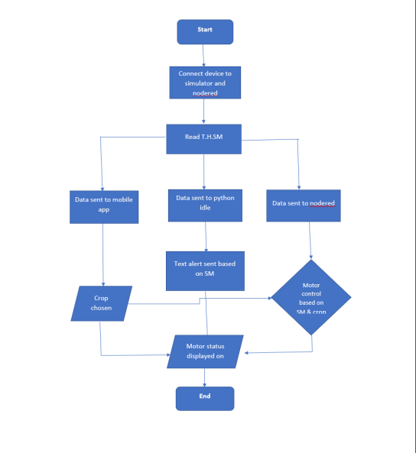

**RESULT :**

One can view the temperature, humidity and soil moisture anywhere and anytime and can control the green house.

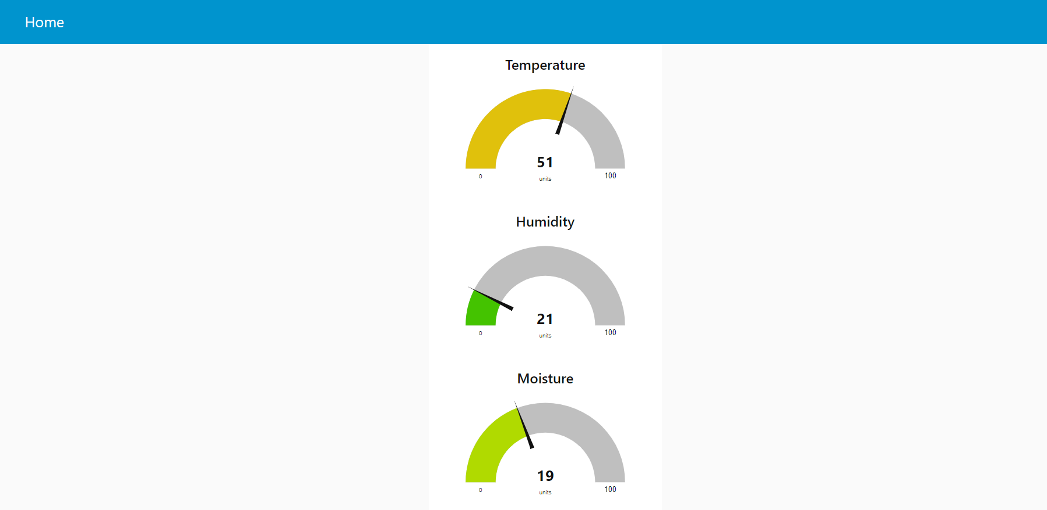

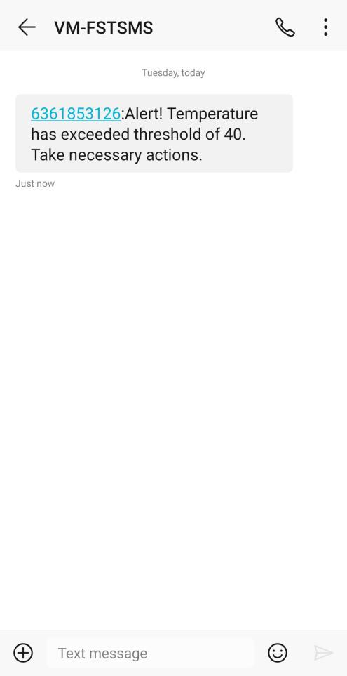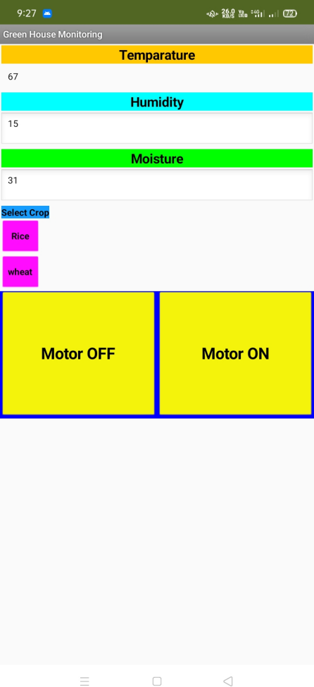

# ADVANTAGES :

* User friendly
* Easily implementable
* Focuses on main parameters
* Uses GSM because of their availability
* Easy network coverage
* Cloud computing procides Increased storage
* Easier group collaboration
* Resource continuity

# DISADVANTAGES :

Requires higher initial capital investment for the distribution system and controls.

# APPLICATION :

Can be used in green houses to control the temperature, soil moisture, hu- midity and light for the proper growth of plants

With little modification, this project can be used in Mechanical companies to measure various parameters of operating machines like temperature and light.

3. Temperature monitoring and controlling action can be used in home or various halls like conference room, seminar hall to control the temperature of room

# CONCLUSION :

This project offers a design of fully automated greenhouse man- agement system. From the experiment it could be seen that it is fulfilling all re-

quirements related greenhouse monitoring. The automatic greenhouse sensor design could help in increasing the productivity of plants. As it has been men- tioned earlier, we are not only providing automatic control over the devices like light, motor pump but also we have a mechanism to alert farmers regarding the parameter changes in the greenhouse so that early precaution steps can be ta- ken. Thus this construction, productivity of cropping can be continuously in- creased so it can handle famine problem around the world.

# FUTURE SCOPE :

We can monitor more parameters like PH of soil, pressure, water level and at the same time control them

We can send this data to a remote location using mobile or internet

We can draw graphs of variations in these parameters using computer

This project can be further enhanced to monitor and control the pesticide le vel

# BIBILOGRAPHY:

* **SmartBridge Videos**
* **[www.google.com](http://www.google.com/)**
* **[www.wikipedia.com](http://www.wikipedia.com/)**

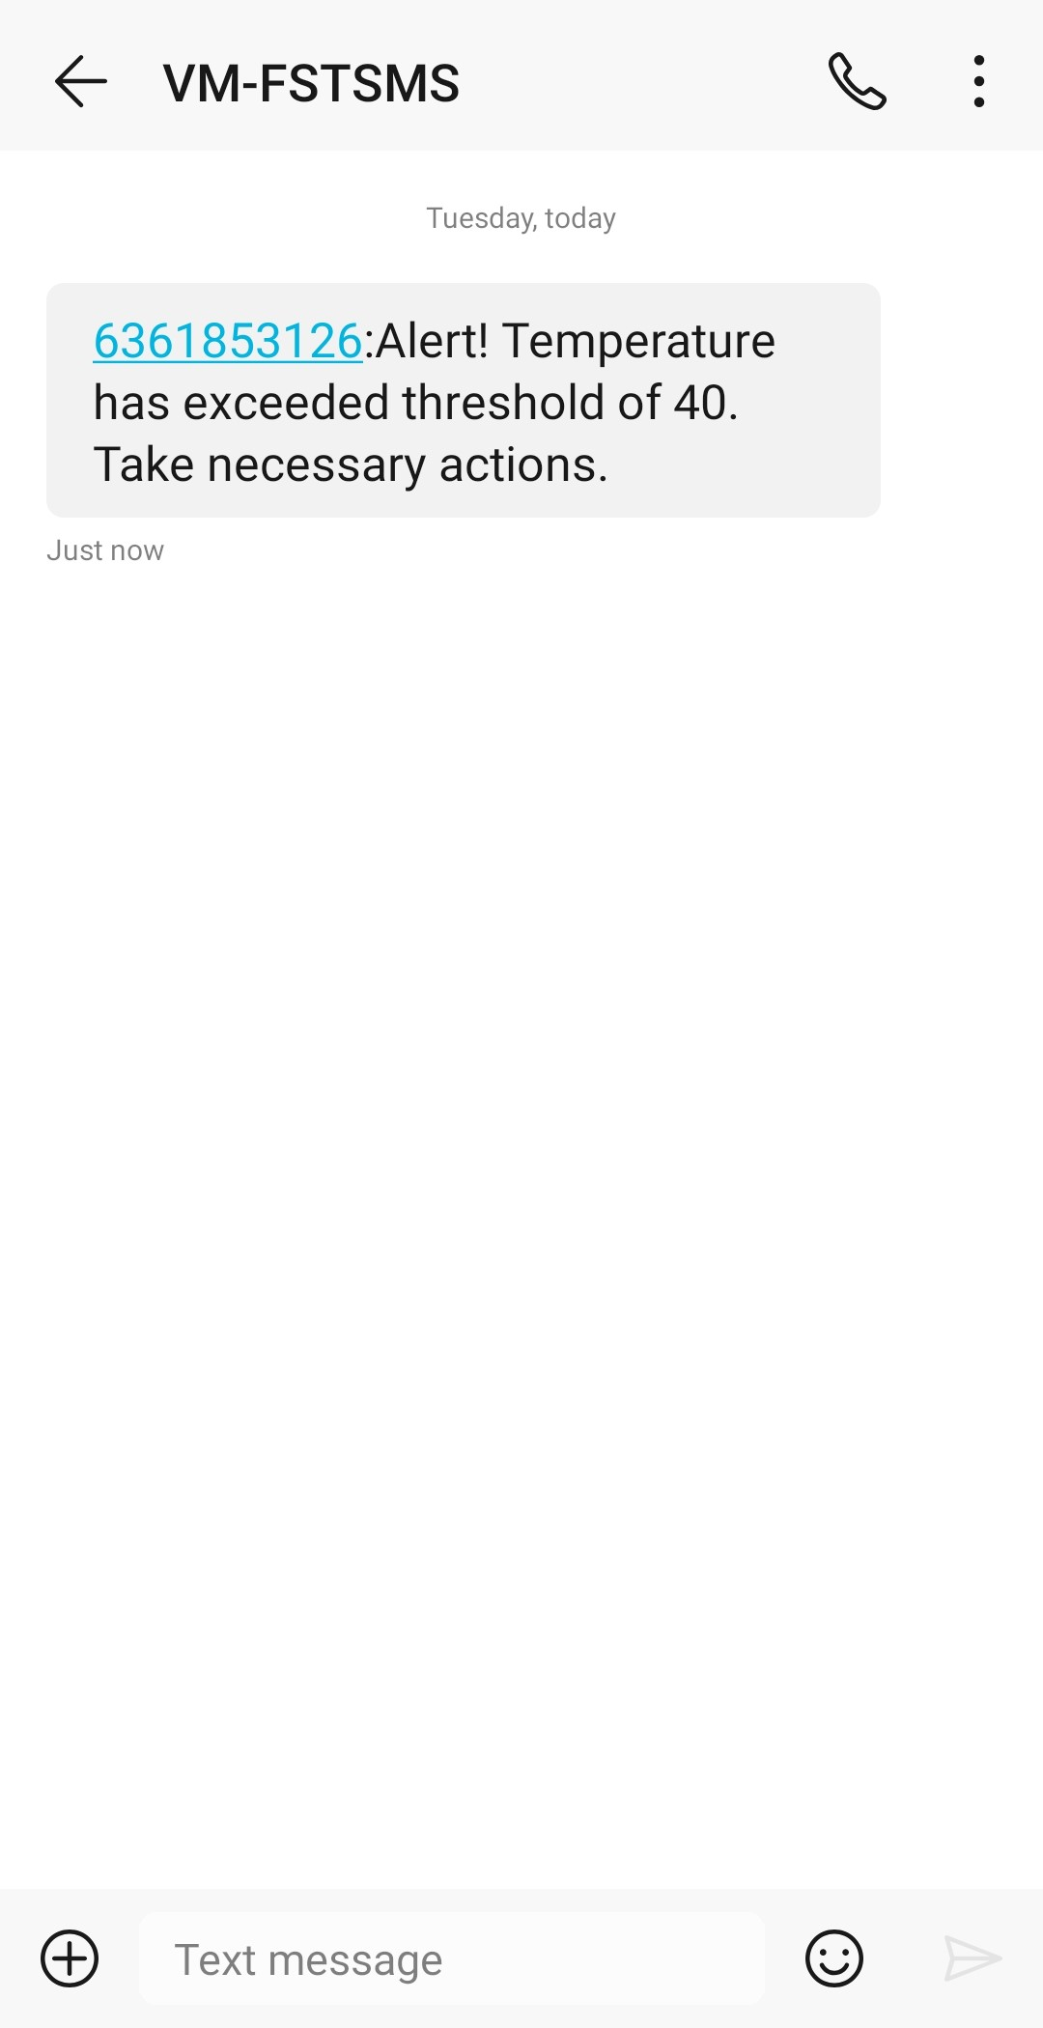[APPENDIX](http://www.wikipedia.com/) :